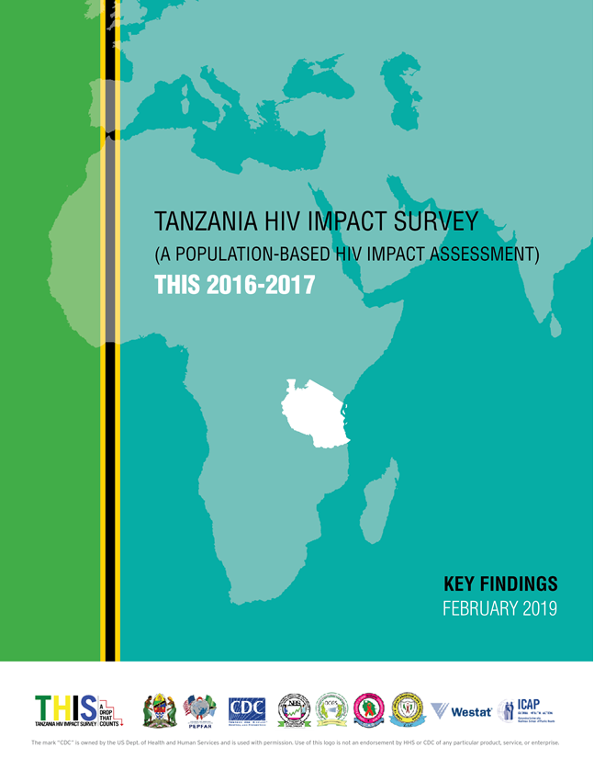

About the 2016-17 Tanzania HIV Impact Survey (A Population –based HIV Impact Assessment)
The Tanzania HIV Impact Survey 2016-2017 (THIS) is the fourth in a series of household-based human immunodeficiency virus (HIV) surveys. The first ever household-based HIV survey was the 2003-04 Tanzania HIV/AIDS Indicator Survey, the second was the Tanzania HIV/AIDS and Malaria Indicator Survey (THMIS) conducted in 2007-08, and this was followed by the 2011-12 Tanzania HIV/AIDS and Malaria Indicator Survey.
THIS is the first national HIV survey that covered populations of all ages and other indicators that were not part of the three surveys conducted previously in the country. These additional indicators included: HIV incidence, CD4 T-cell count, viral load (VL) suppression (VLS), antiretroviral (ARV) drug resistance and presence of ARV drugs in the blood; HIV prevalence among children aged 0-9 years, early adolescent children aged 10-14 years, and elders aged 50 years and older; and the prevalence of syphilis, acute or chronic hepatitis B, and past or current hepatitis C.

Who Implemented The Survey
THIS was led by the Government of Tanzania through the Tanzania Commission for AIDS (TACAIDS) and Zanzibar AIDS Commission (ZAC), and the Ministry of Health, Community Development, Gender, Elderly and Children (MoHCDGEC), the Ministry of Health Zanzibar (MoH), National Bureau of Statistics (NBS) and the Office of Chief Government Statistician (OCGS). THIS was conducted with funding from the U.S. President’s Emergency Plan for AIDS Relief (PEPFAR) and technical assistance through the U.S. Centers for Disease Control and Prevention (CDC) and ICAP at Columbia University.
The survey was implemented by NBS, OCGS, and ICAP in collaboration with local partners, including the the National Health Laboratory - Quality Assurance and Training Center (NHL-QATC), the National AIDS Control Programme (NACP), and the Zanzibar Integrated HIV, Hepatitis, Tuberculosis and Leprosy Program (ZIHHTLP).

Survey Objectives
The goal of THIS was to estimate HIV incidence and prevalence in Tanzania, to assess the coverage and impact of HIV services at the population level, and to characterize HIV-related risk behaviors using a nationally representative sample of adults and children. Primary and secondary objectives included the following:

Primary Objectives
- To estimate national-level annual HIV incidence among adults aged 15-64 years; and
- To estimate regional-level prevalence of VLS (VLS; defined as HIV RNA less than 1,000 copies/mL of plasma) among HIV-positive persons aged 15‐64 years.
Secondary Objectives
- To estimate national-level prevalence of HIV among persons aged 0-14 years;
- To estimate national and regional-level prevalence of HIV among persons aged 15 years and older;
- To assess CD4 count distribution, presence of ARVs, and transmitted drug resistance among PLHIV;
- To describe the socioeconomic and behavioral risk factors associated with HIV infection in a household-based, nationally representative sample;
- To estimate syphilis prevalence in a household-based, nationally representative sample of persons aged 10 years and older;
- To estimate current hepatitis B prevalence and prevalence of past or current hepatitis C in a household-based, nationally representative sample of persons aged 15 years and older; and
- To estimate national and regional coverage of HIV testing.

Who Participated in The Survey
The survey interviewed 14,811 households. In the households surveyed, 36,087 adults aged 15 years and older and 10,452 children aged 0-14 years (7,477 children aged 0-9 years and 2,975 early adolescents aged 10-14 years) were eligible to participate in the survey. Altogether, 33,004 (91.5%) of the eligible adults were interviewed, and of those interviewed, 31,579 (95.7%) had blood drawn for biomarkers assessment to determine HIV and syphilis status. Among those aged 0-14 years, 97.0% (10,141) of eligible children were interviewed and 94.8% of those (9,616) had blood drawn for biomarkers assessment to determine HIV status. Among those aged 10-14 years, biomarker assessment also included syphilis testing, which contributed to estimates of syphilis prevalence. A subset of 1,310 adults were tested for hepatitis B surface antigen (HBsAg), indicative of acute or chronic HBV infection and 4,874 adults were tested for HCV antibody (anti-HCV) indicative of previous infection with HCV or current acute or chronic hepatitis C.
Characteristics of Households
Overall, the majority of the households (71.4%) were male-headed. This distribution was similar between urban and rural areas: 69.3% of urban households were male-headed, while 72.8% of rural households were male-headed. Zanzibar had a lower percent of female-headed households (19.1%) compared to Tanzania mainland (28.8%). The median household size in Tanzania was four members and the median number of children under the age of 18 years in households was two members. The distribution of survey participants by age, sex and residence is presented below.

Percentage of household population by age, sex, and residence, THIS 2016-2017
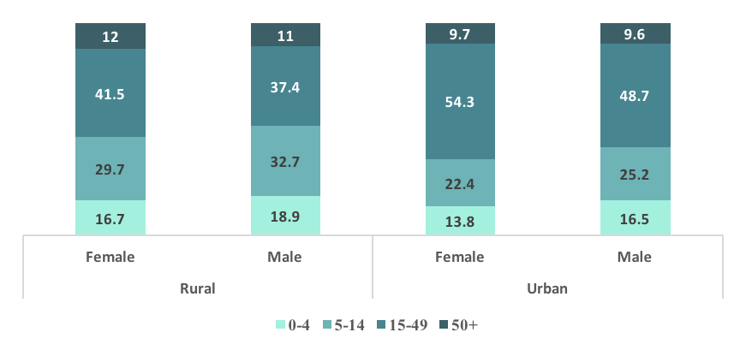

Characteristics of Respondents
Ninety-seven percent (97.3%) of the adult survey population, ages 15 years and older, reside in Tanzania mainland and 2.7% reside in Zanzibar. Of the population of children aged 0-14 years, 97% resides in Tanzania mainland and 3% reside in Zanzibar.
Among the population aged 0-14 years, 71.6% are under the age of 10 years. Sixty-three percent (63.2%) of adults, ages 15 years and older and 71.9% of children, ages 0-14 years, reside in rural areas.
Among the respondents, ages 15 years and older, only 5.2% had more than secondary education. More than half (58.6%) of the respondents, ages 15 years and older, had attended primary education, while nearly one in five (19.1%) had some secondary education.
Eleven percent (11.3%) of adolescents, ages 10-14 years, were not currently attending school while the majority (80.5%) were in primary education.

HIV Incidence
HIV incidence is the measure of new HIV infections in a population over time. It can provide important information on the status of the HIV epidemic, can be used for effective targeted HIV prevention planning in groups that are most vulnerable to infection, and to measure the impact of HIV prevention programs. HIV incidence is expressed as the cumulative incidence or risk of new infections in a 12-month period, which is a close approximation to the instantaneous incidence rate. It is important to note that THIS was not designed to estimate incidence at the regional level or across different sub-groups
The incidence of HIV infection among adults aged 15 years and older is 0.24% overall (0.16% among males and 0.32% among females). This corresponds to approximately 72,000 new infections per year (about 24,000 among males and 48,000 among females). Among adults aged 15-49 years, the estimated HIV incidence was 0.24% and, for those aged 15-64 years, it was 0.25% (0.17% among males and 0.34% among females). Among males, annual incidence peaked in those aged 35-49 years (0.37%) and among females, annual incidence peaked in those aged 25-34 years (0.70%).
The incidence of HIV infection among adults aged 25-34 years is higher (0.43%) compared to other age groups. Females were almost five times more likely to be HIV positive compared to males (0.15% among males and 0.7% among females) in that particular age group.

Annual HIV Incidence using Lag/VL treating algorithm, THIS 2016-2017
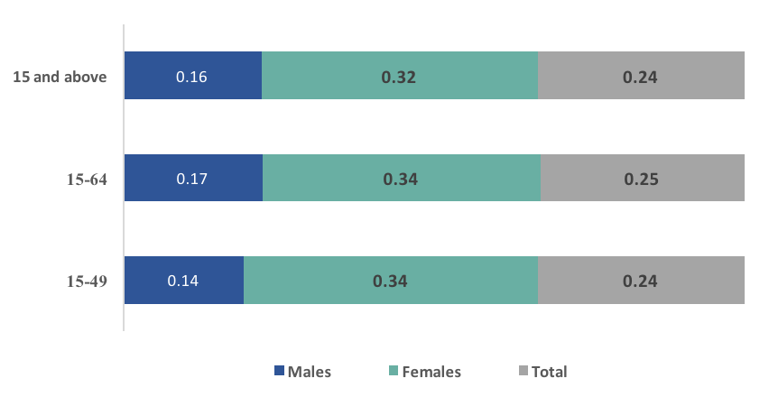

HIV Prevalence
Prevalence of HIV infection among adults aged 15 years and older in Tanzania was 4.9% (6.3% among females, and 3.4% among males). This corresponds to approximately 1.4 million PLHIV aged 15 years and older in the country.
Prevalence among adults aged 15-49 years is 4.7% for the entire country (3.1% among males and 6.2% among females) with higher prevalence in urban areas at 5.5%, as compared to 4.2% in rural areas, 4.8% in Tanzania mainland and 0.4% in Zanzibar.
HIV Prevalence by Age Group
HIV prevalence among females aged 20-24 years, 25-29 years, 30-34 years, and 35-39 years is higher than in males in corresponding age groups.

Percentage of HIV Prevalence by Age-group and sex, THIS 2016-2017
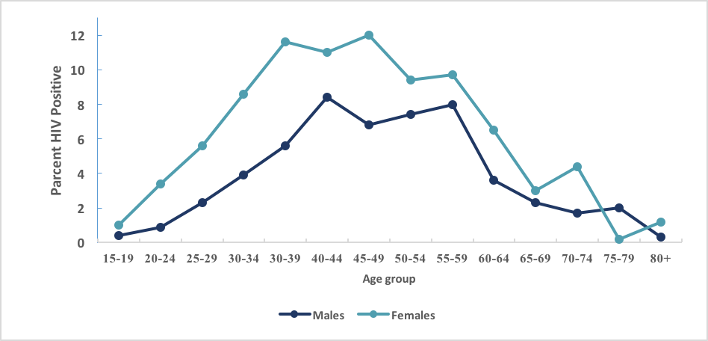

HIV Prevalence by Education
Overall, prevalence decreased with increasing education level. Among adults aged 15 years and older, HIV prevalence by education status ranged from 6.1% in those with no education to 0.5% in those with post-secondary (A-Level) training. HIV prevalence was 6.1% among those with no education, compared to 5.5% among those with primary school education and 2.7% among those with secondary/O-level education. HIV prevalence in females with no education, primary education, and secondary (O-level) education was 6.7%, 7.2% and 3.6%, compared to males with the same level of education 5.0%, 3.7%, and 2.0% respectively.

Percentage of HIV Prevalence for the population of age 15-49 years by level of education and sex, THIS 2016-2017 (Figure to be in four categories – No education, Primary Education, Secondary and University)
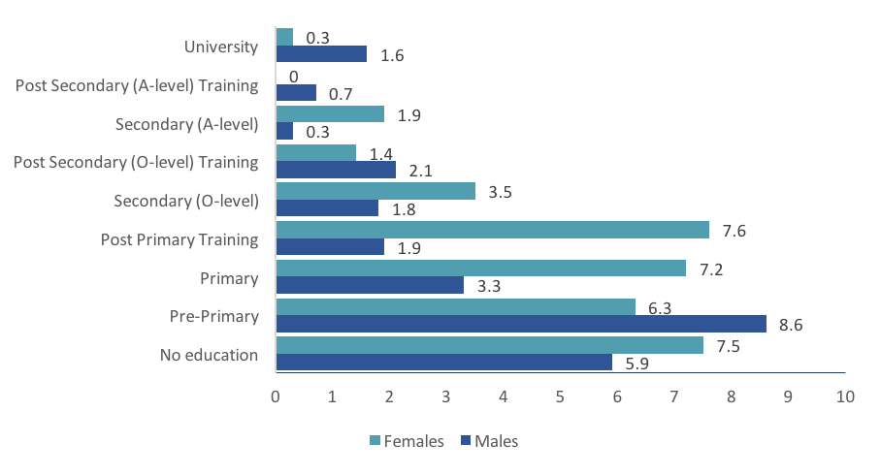

HIV Prevalence by Marital Status
Overall, females have a higher burden of HIV compared to males. Among those aged 15 years and older, who have never married, HIV prevalence is 1.8%. HIV prevalence in females who are never married is approximately three-fold greater (3.1%) compared to men who are never married (0.9%). Among those who are married or living with a partner (or living together), HIV prevalence is 4.8%. Among those who are widowed, divorced, or separated, HIV prevalence is more than twice as high as in those who are married (widowed 13.0%, divorced/separated 11.0%.

Percentage of HIV Prevalence of population aged 15-49 years by Marital Status, THIS 2016-2017
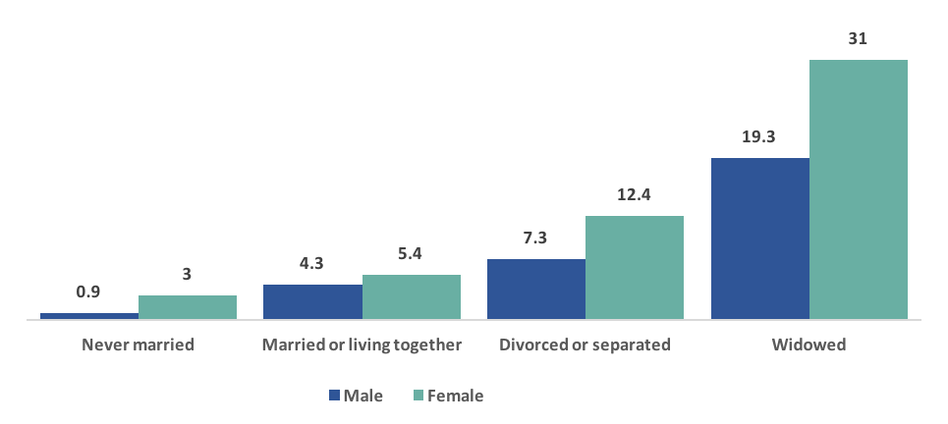
HIV Prevalence by Region
The burden of HIV infection varies across the country; HIV prevalence of population aged 15 years and above ranged from less than 1.0% in Zanzibar regions and Lindi region to 11.4% in Njombe region.

HIV prevalence among adults aged 15 years and older, by region, THIS 2016-2017
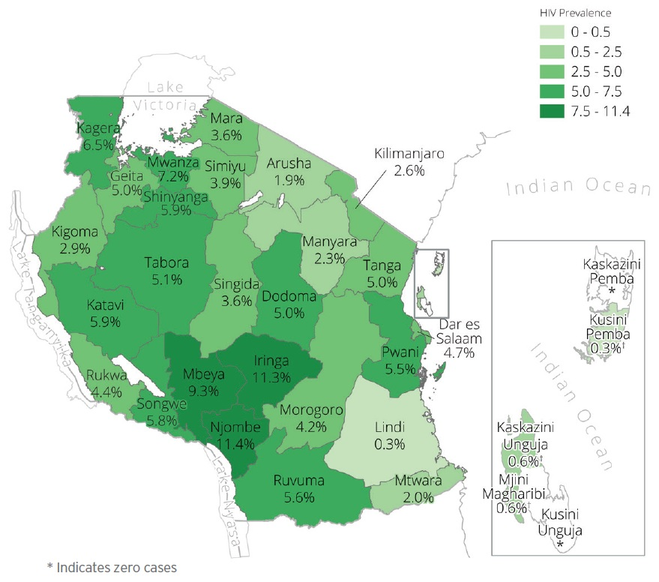

Households With HIV Infected Members
In Tanzania, 9.9% of households has at least one HIV-positive member (11.8% of urban households and 8.7% of rural households). Among HIV-affected households, 82.8% has one HIV- positive member and 16.3% has two HIV-positive members. This distribution is almost similar for urban and rural households. Overall, 7.1% of households in Tanzania has an HIV- positive head of the household. Of the male-headed households, 4.8% are headed by an HIV-positive male. Among female-headed households, 12.0% are headed by an HIV-positive female.

Percentage of Prevalence of households with an HIV positive head of household by Residence | Prevalence of households with an HIV-positive head of household by sex, THIS 2016-2017
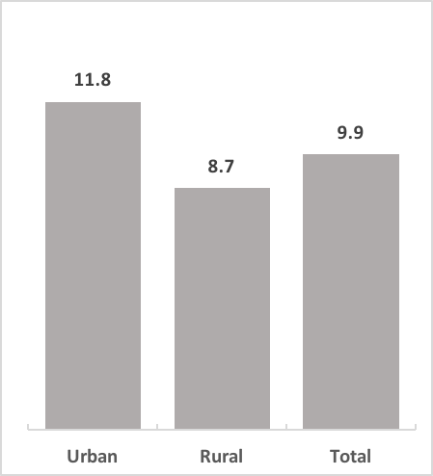 | 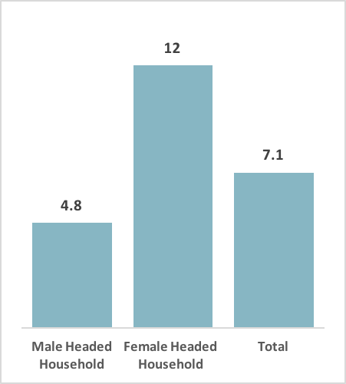

HIV Testing
Awareness of HIV status is a critical component of HIV epidemic control. Awareness of HIV-positive status is the first step to engagement with HIV care and treatment services, accessing ART, prevention and counseling. Testing is essential for both HIV-positive and HIV-negative individuals to reduce risk of HIV transmission or acquisition, and access to screening services for other comorbidities.  In Tanzania, 15.7% of adults aged 15 years and older who tested HIV positive during THIS reported that they had never been tested for HIV previously (19.7% of males and 13.7% of females) | HIV testing during Field Staff Biomarker training
 | 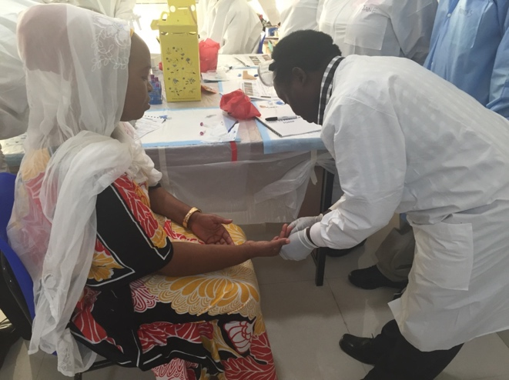

Sixty-five percent (65.2%) of adults 15 years and older self-reported having ever been tested for HIV (59.2% of males and 70.8% of females). There is low HIV testing in the adolescents aged 15-19 years: 79.0% of males and 61.4% of females reporting never testing for HIV. Self-report of HIV testing was lower among people who were not educated compared to those who had a university education (54.4% versus 89.3%). About forty-one percent (40.8%) of males and 29.2% of females aged 15 and older have never had an HIV test.

Overall, 31.3% of adults aged 15 years and older reported having had an HIV test in the twelve months preceding the survey (29.0% of males and 33.5% of females).

Self-Report HIV Testing: Percentage of population aged 15 years and older who received HIV testing in the past 12 months and received the results
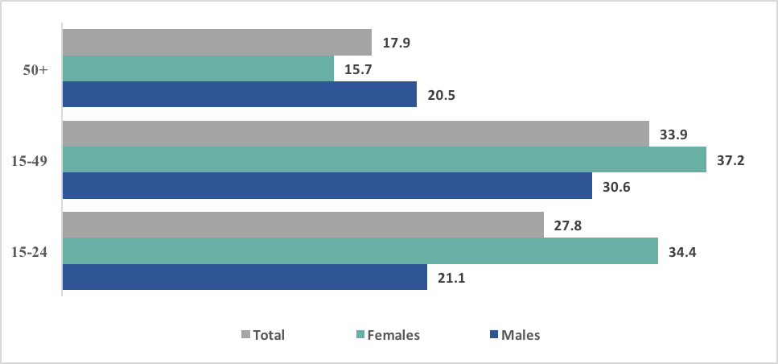
HIV Diagnosis and Treatment
Based on self-reporting of HIV status, among HIV-positive adults aged 15 years and older, 51.8% were aware of their HIV-positive status (45.2% of males and 55.3% of females). Among those who reported that they had not been previously diagnosed, 9.7% had ARVs detected in their blood (4.8% among males and 12.8% among females).

Percent distribution of HIV positive population aged 15 years and older by self-reported HIV diagnosis status on unaware of HIV Status
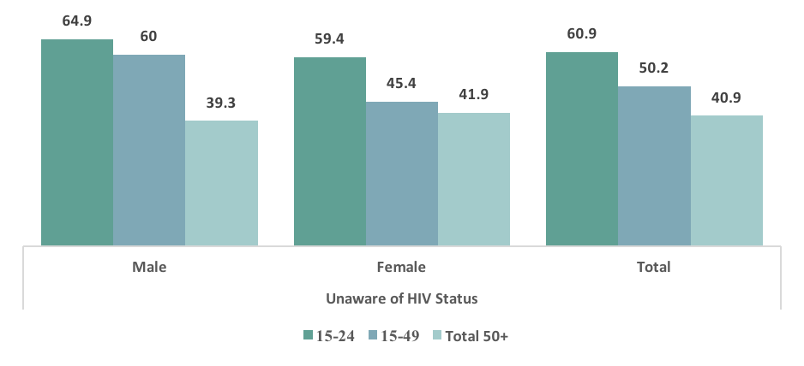

Among those HIV-positive adults aged 15 years and older who self-reported knowing their status and being on ART, 94.9% had detectable ARVs in their blood.
Overall, 47.1% of HIV-positive adults reported awareness of their status and ART use (38.8% for males and 51.4% for females). ARVs were detected in 54.6% of HIV-positive adults aged 15 years and older.

There is a gap in reaching and diagnosing people living with HIV, especially males of all ages, and young people aged 15-24 years. Sixty-one percent (60.9%) of HIV-positive individuals aged 15-24 years were unaware of their HIV status.

Percent distribution of HIV positive population aged 15 years and above who are aware of their HIV status and self-reported HIV Treatment status
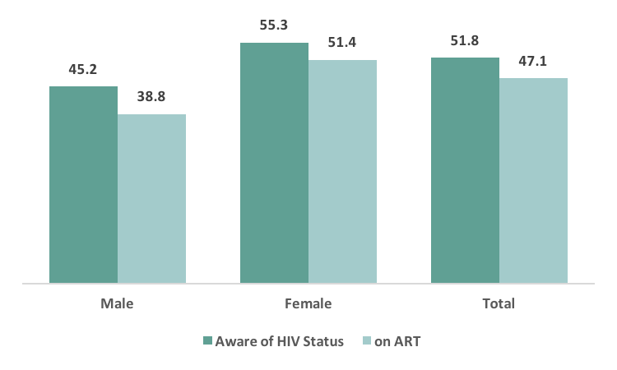

Viral Load Suppression
Viral load suppression is a key indicator of treatment success in HIV-positive individuals. For the purposes of THIS, VLS was defined as VL less than 1,000 HIV RNA copies/mL of plasma.  Overall, 51.9% of HIV-positive adults aged 15 years and older, had VLS (41.5% among males and 57.2% among females).  The percentage of HIV positive adults aged 15 years and older with VLS ranged from 32.4% in Geita region to 66.0% in Kagera region.  Almost eighty eight percent (87.8%) of adults aged 15 years and older on ART had VLS (84.4% of males and 89.1% of females). | Adolescents and young adults aged 15-24 years had comparatively lower VLS with 41.5% having a suppressed viral load (22.2% for males and 47.1% for females).  Biomarker processing in the Satellite Lab in Tanzania
 | 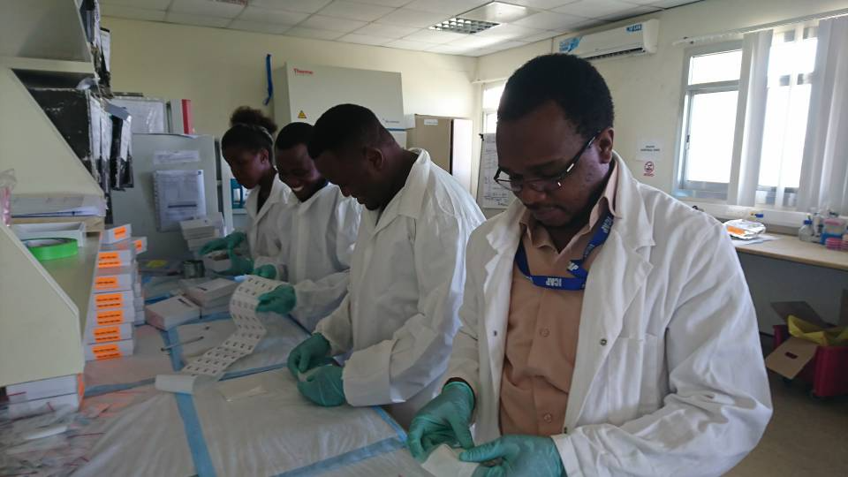

Percent of HIV-positive persons aged 15 years and older with viral load suppression (< 1,000 copies/mL)1, by sex, self- reported diagnosis and ART status
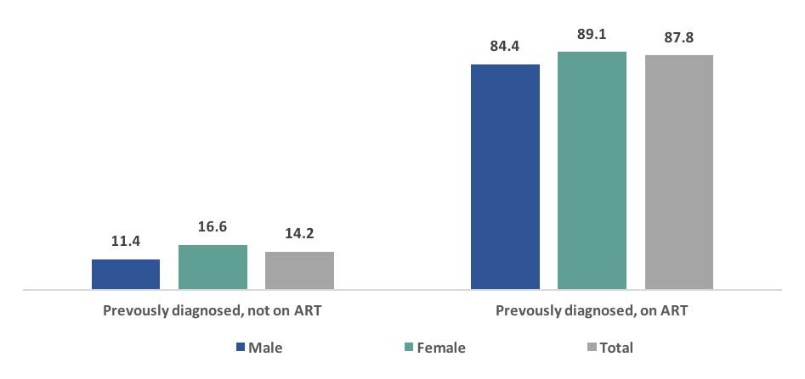

Viral load suppression (<1000 copies/mL) among HIV-positive adults aged 15 years and older, by region, THIS 2016-2017

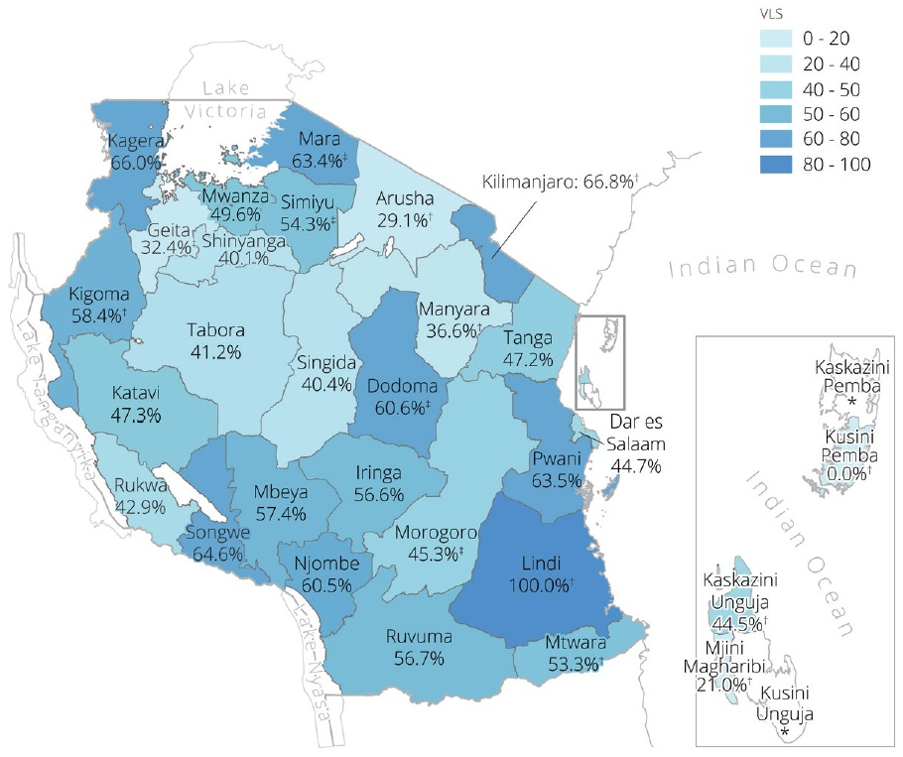

UNAIDS 90-90-90 Targets
In order to bring the HIV epidemic under control, UNAIDS has set ambitious targets referred to as 90-90- 90: that is by 2020; 90% of all PLHIV will know their HIV status; 90% of all persons with diagnosed HIV infection will receive sustained ART; and 90% of all persons receiving ART will have VLS.

Diagnosis: About sixty one percent (60.6%) of adults 15 years and older living with HIV, know their HIV-positive status as determined by a combination of both self-report and ARV detection in their blood (52.2% in males and 64.9% in females).

On treatment: Of those 15 years of age and older who were aware of their HIV-positive status, 93.6% were on ART based on a combination self-report and ARV detection (89.6% in males and 95.3% in females).

Viral load suppression: Among those 15 years of age and older who were on treatment, 87.0% had suppressed viral loads (83.2% in males and 88.6% in females).

A gender gap is apparent for each of the three 90’s. In comparison to males, a greater proportion of females were diagnosed.

Age groups also varied in each of the 90’s and provide in sight for programmatic focus. For example, only half of those aged 15-24 years (50.2%) living with HIV were aware of their status of which 92.6% were on treatment; and 83.5% had suppressed viral loads.

Adult 90-90-90 (adjusted for Laboratory Antiretroviral data among adults aged 15 years and older) THIS 2016-2017
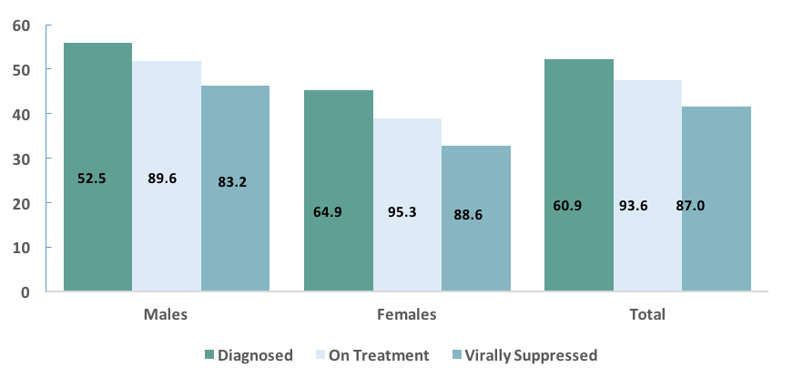
Clinical Perspective on People Living with HIV
It is vital to assess indicators that show the potential impact of HIV on overall morbidity and mortality as well as HIV program effectiveness. The distribution of CD4 counts reflects population health, and indicates the stage of HIV disease progression (immunosuppression level) among PLHIV. Treating PLHIV at higher CD4 counts improves immune recovery, decreases the incidence of non-AIDS events, comorbidities, and mortality, and reduces transmission.  The proportion with immunosuppression (CD4 counts less than 500 cells/μL) was 61.8% among all HIV-positive individuals aged 15 years and older (73.8% in males, 55.7% in females). | CD4 Testing using PIMA Machine
 | 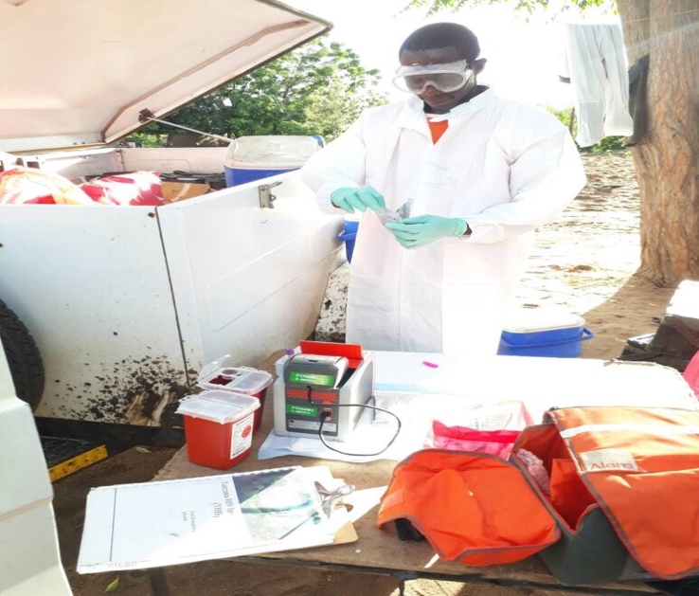
Median CD4 cell count among individuals who have not been previously diagnosed with HIV was 388 cells/μL compared to 420 cells/μL and 467 cells/μL in those previously diagnosed but not on treatment and those diagnosed and receiving treatment, respectively.

Among adults aged 15 years and older living with HIV who had not been diagnosed, 21.6% of males and 18.5% of females had severe immunosuppression with CD4 count less than 200 cells/μl.

Advanced immunosuppression (CD4 counts less than 350 cells/μ) among undiagnosed PLHIV aged 15 years and older is common (45.1%); it is highest among those aged 50 years and older (53.1%).

Median CD4 Counts among HIV-positive persons aged 15 years and older by Marital Status
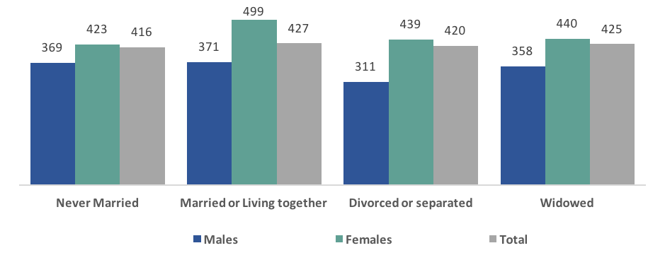

Prevention of Mother to Child Transmission
According to WHO (2002), over 90% of new infections among infants and young children occur through mother-to-child transmission (MTCT). Without any interventions, between 20% and 45% of infants may become infected through MTCT, with an estimated risk of 5%-10% during pregnancy, 10%- 20% during labor and delivery, and 5%-20% through breastfeeding (De Cock KM, Fowler MG, Mercier E, et al)
Among women aged 15-49 years, 98.9% attended at least one ANC visit for their most recent pregnancy during the three years prior to the survey.

Percentage of females attended Antenatal care by age group
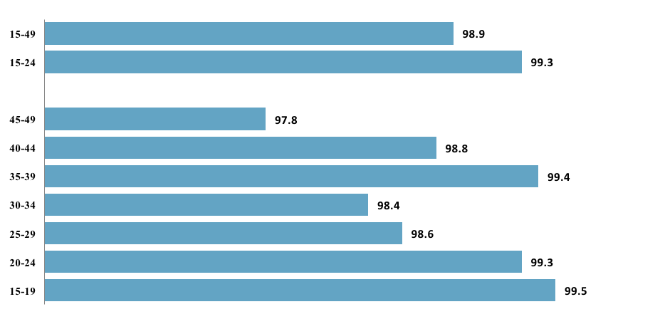

Among all women aged 15-49 who gave birth during the 12 months preceding the survey, 92.4% knew their HIV status.
Among HIV-positive women aged 15-49 years who gave birth during the 12 months preceding the survey, 97.9% received ARVs; 51.9% of these women were newly initiated on ARVs during pregnancy, labor, or delivery.

ANC HIV testing is lower in rural compared to urban areas. Approximately half (51.9%) of HIV-positive women reported first initiation on ARVs during pregnancy. Given the high numbers of infections in young women, there could be more emphasis on diagnosis and treatment of women before they begin childbearing. Evidence shows that MTCT rates are lower if women are on ART before pregnancy.

Children, Adolescent and Young Adults
For the first time in Tanzania, THIS provides direct measurements of prevalence of HIV among children aged 0-14 years, the number of children living with HIV (CLHIV) and viral suppression among CLHIV.
The estimated prevalence of HIV infection among children aged 0-14 years was 0.4 %. Based on parents’ reports and ARV detection data, it is estimated that 50.1% of children living with HIV in Tanzania were diagnosed. Overall among children under the age of 0-14 years living with HIV, 81.6% did not have VLS.

Among those aged 15-24 years, a higher proportion of males (14.3%) than females (9.1%) reported having had sex before age 15 years.
A higher proportion of those aged 15-24 years that were rural residents (13.4%) reported having had sex before 15 years of age compared to those aged 15-24 years that were urban residents (9.0%).
A higher proportion of those aged 15-24 years in Tanzania Mainland (12 %) reported having had sex before 15 years of age compared to 2.6% in Zanzibar.

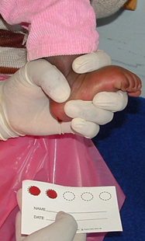
Overall, there is still a challenge in HIV testing among those aged 15-24 years (49.0% were aware of their HIV-status), and the gap is seen more in males (37.9% were aware of their HIV status).

The difference in HIV prevalence between females and males is highest in the age group 20-24 years (3.4% among females and 0.9% among males).

HIV Risk Factors
Approximately one-third (31.7%) of adults aged 15 years and older who reported having sex in the 12 months preceding the survey with a non marital, non cohabitating partner used a condom at last sexual intercourse.

HIV prevalence among persons aged 15 years and older who reported that they used a condom at the last sexual intercourse in the past 12 months was 9.0%, compared to 4.2% among persons who reported that they did not use a condom. The percentage of HIV-positive females who used a condom at the last sexual intercourse in the past 12 months was higher (13.9%) than the percentage among HIV-positive males (5.3%).

Percentage of HIV prevalence by the age at first sexual intercourse | Among adults aged 15 years and older who had sexual debut before the age of 15 years, the prevalence of HIV infection was higher for females (7.0%) than for males (4.4%).
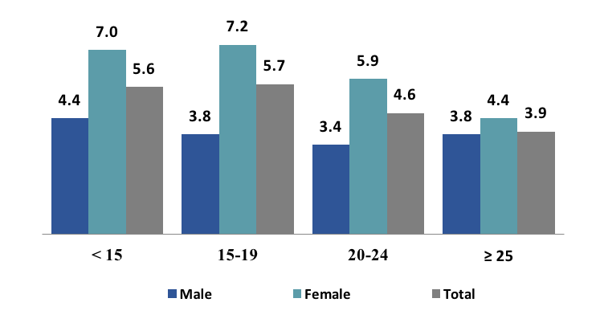

There are differences in HIV prevalence by age at sexual debut, with HIV prevalence of 5.6% among those who had sex before the age of 15 years and HIV prevalence of 3.9 % among those with sexual debut over the age of 25 years.

Regardless of number of sexual partners in the last 12 months, females had a higher HIV prevalence than males. HIV prevalence of females who had two or more sexual partners in the last 12 months was nearly three times as high (12.0%) compared to males (4.2%). | Percentage of HIV prevalence by the number of sexual partners in the past 12 months
 | 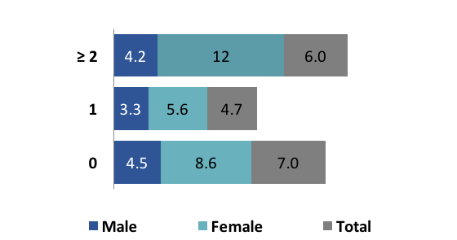

The THIS defined paid sexual intercourse as paying or receiving money for sexual intercourse. HIV prevalence in adults aged 15 years and older who reported engaging in paid sexual intercourse in the 12 months preceding the survey was higher than those who did not (7.8% versus 4.7%, respectively). Females who reported having engaged in paid sexual intercourse had nearly twice the HIV prevalence (11.2%) compared to males (5.9%).

Discriminatory Attitudes Towards People Living with HIV
The role that stigma plays in increasing the spread of HIV has been identified in the Tanzanian Policy on HIV/AIDS (2001) and the Health Sector HIV/AIDS Strategic Plan IV (HSHSP 2017-2022). Stigma reduction is recognized as a key guiding principle that must be addressed by all sectors at all levels.

Among adults aged 15 years and older who had ever heard of HIV, 25.6% reported discriminatory attitudes towards PLHIV. More adults in rural areas (30.6%) reported discriminatory attitudes towards PLHIV, compared to those in urban areas (17.1%) in Tanzania Mainland. Discriminatory attitudes were slightly more prevalent in Zanzibar (30.5%) compared to mainland Tanzania (25.5%). | Percentage who reported discriminatory attitudes toward PLHIV among persons aged 15 years and above by Residence
 | 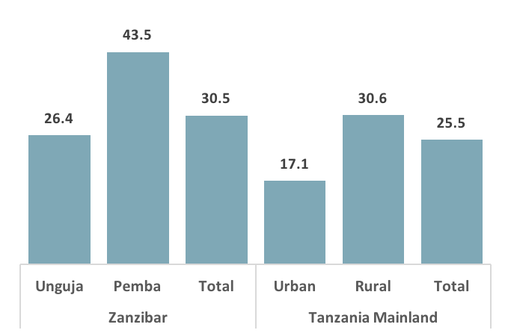

Variation in discriminatory attitudes occurs across different levels of educational attainment; 41.7% of those with no education reported discriminatory attitudes in contrast to 12.2% among those with A level secondary education and 9.3% among those with university education.

Percentage who reported discriminatory attitudes toward PLHIV among persons aged 15 years and above by level of education attainment
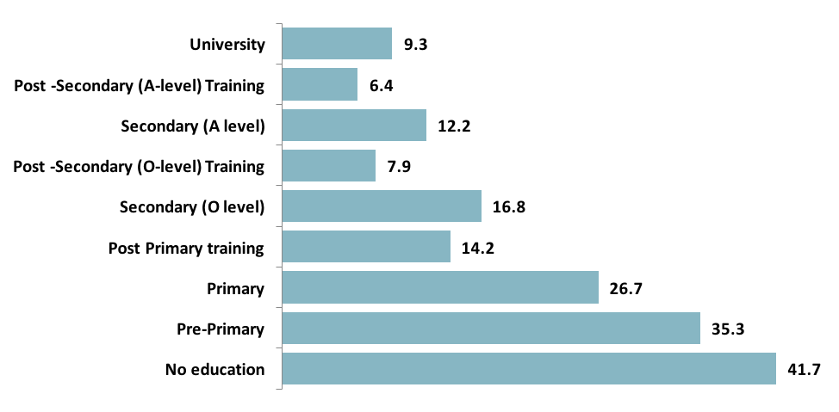

Discriminatory attitudes towards PLHIV are higher among persons aged 50 years and older compared to adults aged 15-49 years (30.7% and 24.7% respectively).

Percentage who reported discriminatory attitudes toward PLHIV among persons aged 15 years and above by age group
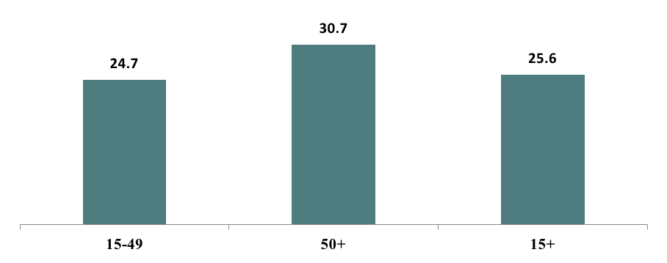

Tuberculosis, Syphilis, Hepatitis B, Hepatitis C, Sexually Transmitted Infection Symptoms and Cervical Cancer
Tuberculosis
PLHIV are at risk for acquiring other diseases, including TB, hepatitis B, hepatitis C, syphilis, and other STIs. TB is one of the leading causes of death for PLHIV. A UNAIDS model estimates that there were 27,000 TB- related deaths among PLHIV in Tanzania in 2016 (UNAIDS 2016).
Among self-reported HIV-positive persons aged 15 years and older, 27.7% reported ever visiting a TB clinic (29.7% of HIV-positive males compared to 26.9% of HIV-positive females). Among those who ever visited a TB clinic, 54.2% were diagnosed with TB. Among those diagnosed with TB, 100.0% of males and 98.1% of females reported receiving TB treatment.

Percent of self-reported HIV-positive persons aged 15 years and older, who ever visited a TB clinic; among those who had ever visited a TB clinic, percentage who were diagnosed for TB; and among those diagnosed with TB, percentage who were treated for TB, by sex, THIS 2016-2017

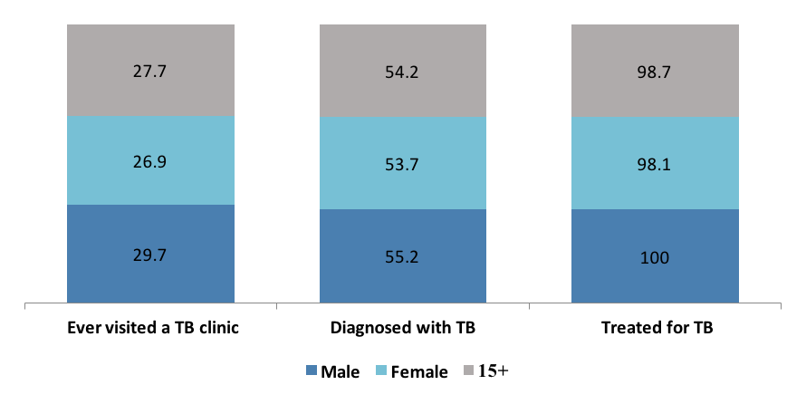

Syphilis
Syphilis in both women and men is associated with serious complications. It remains the leading cause of perinatal mortality and morbidity in many parts of the world despite widely available and affordable technology for diagnosing and treating infection in pregnant women.
In the general population, among individuals aged 15 years and older tested for syphilis, 5.6% (5.6% males and 5.5% females) were ever infected by syphilis, and, among them, 0.9% (1.0% males and 0.9% females) had active infection. Active syphilis infection was higher among HIV-positive (3.7%) than among HIV-negative (0.8 %) persons.

Hepatitis B
Hepatitis B is one of the blood borne diseases routinely screened among individuals donating blood at the blood bank in Tanzania. THIS tested individual aged 15 years and older to get prevalence of hepatitis B surface antigen (HBsAg) in the general population, indicative of active infection (either acute or chronic). Among adults aged 15 years and older, prevalence of HBV infection for HIV-positive individuals (5.2%) was higher than for HIV-negative individuals (3.4%). The prevalence of hepatitis B was higher among married or living together individuals (4.6%) than those who were never married (2.1%), divorced or separated (2.7%), and widowed (1.5%).
Among adults aged 15 years and older, the prevalence of hepatitis B was 3.5%. The highest prevalence of hepatitis B was among those aged 35-39 years (10.2%).

Hepatitis C
Among adults aged 15-64 years, anti-HCV positivity prevalence, indicative of past or current hepatitis C virus infection, was 1.0% overall, and slightly higher among females (1.2%) than males (0.8%). HIV positivity in combination with anti-HCV positivity was low, less than one percent of HIV-positive males aged 15-64 years testing positive for anti-HCV and 0.7% of HIV-positive females testing positive for anti-HCV. Among the HIV-negative population aged 15-64 years, 0.8% of men and 1.3% of women tested positive for anti- HCV.
Prevalence of past or current hepatitis C among adults aged 15-64 and 15-49 years was 1.0% overall.

Percent of Prevalence of Hepatitis B (positive for hepatitis B surface antigen) and Hepatitis C (positive for hepatitis C virus antibody) among person aged 15-49 years, THIS 2016-2017
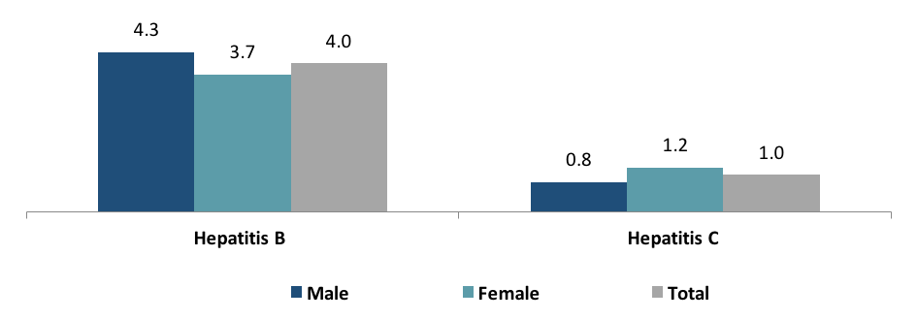

Sexually Transmitted Infections (STI)
Individuals living with HIV had a higher prevalence of abnormal discharge and ulcers than those not living with HIV.
Percent of persons aged 15 years and older who self-reported symptoms of a Sexually Transmitted Infections in the 12 months preceding the survey by HIV status and sex, THIS 2016-2017
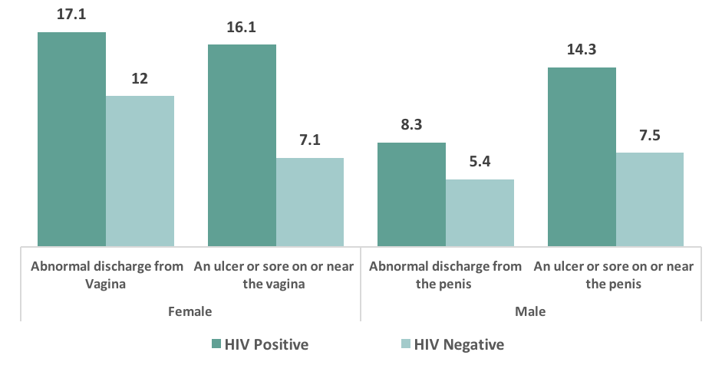
Cervical Cancer
Among HIV-positive women aged 30-49 years, 17.7% reported having ever been screened for cervical cancer. A slightly higher percentage of women in urban areas (20.5%) than in rural areas (15.1%) reported having ever been screened for cervical cancer.

Screening for cervical cancer also differed by women’s education. Among women with O-Level secondary education, 28.4% had ever been screened for cervical cancer, compared to 15.2% of women with no education. According to Marital Status, widower has higher percentage of cervical cancer screening compared to other groups of marital status.

Among HIV-positive women aged 30-49 years, percentage who report being screened for cervical cancer, by Marital status, THIS 2016-2017
